Project Design Phase-II
Technology Stack (Architecture & Stack)
Date | 04 October 2026
Team ID | SWTID-2026-6870
Project Name | Streamlining IT Procurement: Automating Standard Laptop Orders with Flow Designer
Maximum Marks | 4 Marks

Technical Architecture
The solution is built on the ServiceNow platform using low-code tools. A Standard Laptop order triggers a Flow Designer flow which creates a catalog task for the Hardware team.
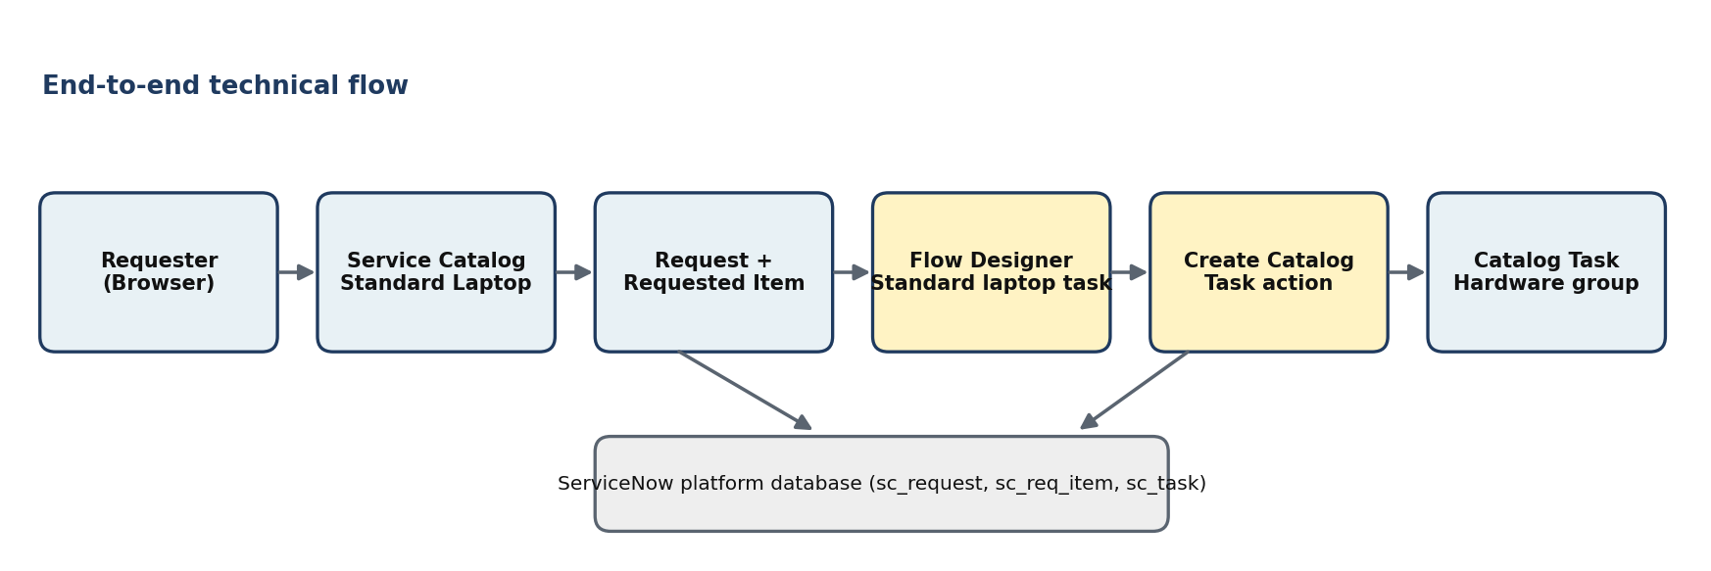
Figure 1: Technical architecture / data flow

Table-1: Components & Technologies
S.No | Component | Description | Technology
1. | User Interface | How the user orders and tracks the laptop request | ServiceNow Service Catalog and platform forms (web browser)
2. | Application Logic-1 | Automation that starts when the item is ordered | Flow Designer – flow "Standard laptop task" with Service Catalog trigger
3. | Application Logic-2 | Creates the configuration task | Create Catalog Task action (ServiceNow Core spoke)
4. | Application Logic-3 | Approval of the request before configuration | Request approval (Approvers related list), approver user
5. | Database | Stores request, requested item and task records | ServiceNow platform tables: sc_request, sc_req_item, sc_task
6. | Cloud Database | Database service on cloud | ServiceNow cloud-hosted instance database
7. | File Storage | File storage requirements | Not required for this project (platform attachments available if needed)
8. | External API | Calls to outside services | None used
9. | Infrastructure | Application deployment | ServiceNow cloud instance (Global application scope)

Table-2: Application Characteristics
S.No | Characteristics | Description | Technology
1. | Open-source frameworks | The solution is configured, not coded; no external frameworks | ServiceNow Flow Designer (low-code)
2. | Security implementations | Role-based access, approval gate, flow runs as System User | ServiceNow roles, ACLs, Run As: System User
3. | Scalable architecture | Same flow design can be copied for other catalog items | Reusable flows and actions
4. | Availability | Cloud platform with managed availability | ServiceNow instance
5. | Performance | Automatic task creation, no manual step | Flow engine of the platform

